Witness Report----------------------------------------------------------------------------------------------->
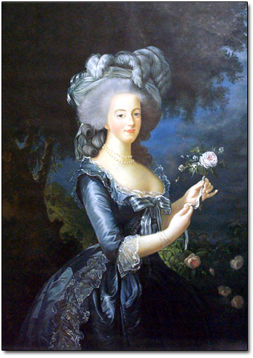
Marie Antoinette -

You married the crown prince of France in 1770. Four years
later you became queen when her husband was crowned King Louis
XVI (House of Bourbon).
The stories of your excesses are vastly overstated. In fact, rather than
ignoring France's growing financial crisis, you reduced the royal
household staff, eliminating many unnecessary positions that were
based solely on privilege. In the process you offended the nobles, adding their condemnation to the scandalous stories spread by royal hopefuls. It was the nobility that balked at the financial reforms the government ministers tried to make, rather than you and the King, who were in favor of change. You weren’t entirely without fault though spending lavishly on a “peasant town.” In 1789 a mob descended on the palace at Versailles and demanded the royal family move to the Tuilerie palace inside Paris. From that point on the King and Queen were virtual prisoners. Antoinette sought aid from other European rulers including her brother, the Austrian Emperor, and her sister, Queen of Naples. After a failed attempt to flee Paris in 1791 Antoinette continued to seek aid from abroad. When Austria and Prussia declared war on France, you was accused of passing military secrets to the enemy. On August 10, 1792 the royal family was arrested on suspicion of treason and imprisoned. On January 21, 1793 King Louis XVI was convicted and executed on the guillotine.
Antoinette was cruely treated during her final days of captivity. You was brought to trial Marie-Antoinette, in this her utter abandonment, and hour of extreme need, is not wanting to herself, the imperial woman. Her look, they say, as that hideous Indictment was reading, continued calm; 'you was sometimes observed moving her fingers,as when one plays on the piano'. You discern, not without interest, across that dim Révolutionary Bulletin itself, how you bears herself queenlike. Her answers are prompt, clear, often of Laconic brevity; resolution, which has grown contemptuous without ceasing to be dignified, veils itself in calm words. 'You persist, then, in denial?' -- 'My plan is not denial: it is the truth I have said, and I persist in that.' Scandalous Hébert has borne his testimony as to many things: as to one thing, concerning Marie-Antoinette and her little Son, -- wherewith Human Speech had better not further be soiled. You has answered Hébert; a Juryman begs to observe that she has not answered as to this. 'I have not answered', you exclaims with noble emotion, ' because Nature refuses to answer such a charge brought against a Mother, I appeal to all the Mothers that are here.' Robespierre, when he heard of it, broke out into something almost like swearing at the brutish blockheadism of this Hébert; on whose foul head his foul lie has recoiled. At four o'clock on Wednesday morning, after two days and two nights of interrogating, jury-charging, and other darkening of counsel, the result comes out: sentence of Death. Her children were taken from her, and her best friend, the Princess de Lambelle, was killed and her severed head was put on a pole and paraded in front of the Queen. Antoinette followed her husband to the guillotine on October 16, 1793. You were executed without proof of the crimes for which you were accused. You were only 37 years old.

Remember to dress and act in character. Make sure you dress as he would have...etc. Don't forget to write a 2-3 page detailed autobiography of your character, the reason you plan to behave as you will on the stand and your purpose in the trial (due the day the trial begins). This page is only to get you started on your research. Use the West Valley of De Anza College libraries and from there go to the even better San Jose State University or Santa Clara University libraries.

