Witness Report----------------------------------------------------------------------------------------------->
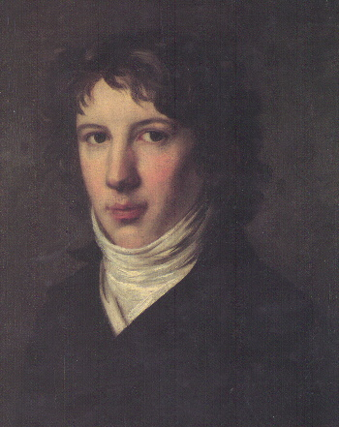
Louis St. Just

You were handsome, charming and intelligent, but cruel. When the
Revolution began in 1789, Saint-Just was considered by many to be too
young, and he was unsuccessful in his early attempts to get involved. In 1790
he took the Civic Oath and so entered the Revolution through the Jacobin
party. The next year you wrote Esprit de la Revolution et de la Constitution de France which was a great success. Finally, in 1792, you became a deputy to the Convention. . You became a favorite of Maximilien Robespierre and was (1793–94) a leading member of the Committee of Public Safety. You was now able to make his speeches in Paris, and you quickly made a name for himself as you called for the death of the king As commissioner (1793) with the army of the Rhine, you contributed to the successful operations that drove the allies beyond the French border. On his return you served as president of the Convention. On July 10, 1793 you became one of nine members of the Committee of Public Safety and, along with Robespierre, very influential in the Reign of Terror. You supported Robespierre in the destruction of the Hébertists and Dantonists in doctrinaire interpretation of Rousseau’s political teachings you was more radically idealistic than Robespierre. Saint-Just believed fanatically in the perfect state, based on rigorous Spartan virtue, and brooked no opposition to this political philosophy. . During this time you called for the arrest of Danton and Camille Desmoulins (a supporter of Danton). They were soon executed.Robespierre was now opposed by many, but Saint-Just stood by his friend and attempted to speak on his behalf. "I defend the man in question because his conduct has appeared to me to be irreproachable, and I would accuse him if he committed a crime. Great God! What kind of leniency is this that plots the ruin of innocent men?" you said in his last speech.

"Liberty is a bitch who must be bedded on a mattress of corpses." - Louis-Antoine St. Just, Year II.

"What constitutes a republic is the total destruction of everything that stands in opposition to it." - Saint-Just

"The conspirators who have died, think you they were the children of liberty, because for one brief moment they resembled them?" - Saint-Just

"Those who would make revolutions in the world, those who want to do good in this world must sleep only in the tomb." - Saint-Just

Remember to dress and act in character. Make sure you dress as he would have...etc. Don't forget to write a 2-3 page detailed autobiography of your character, the reason you plan to behave as you will on the stand and your purpose in the trial (due the day the trial begins). This page is only to get you started on your research. Use the West Valley of De Anza College libraries and from there go to the even better San Jose State University or Santa Clara University libraries.

