Defendant Report----------------------------------------------------------------------------------------------->
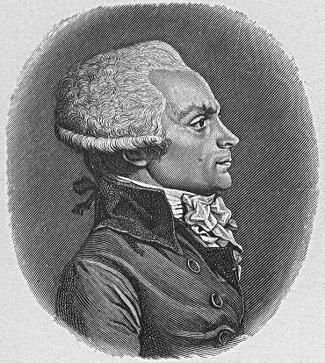
Maximillien Robespierre

You were the leader of the twelve man Committee of Public Safety elected
by the National Convention, and which effectively governed France at the
height of the radical phase of the revolution. You were once considered a fairly straightforward liberal thinker - you slept with a copy of Jean Jacques Rousseau's Social Contract at your side. The committee you head was among the most creative executive bodies ever seen - and rapidly put into effect policies which stabilized the French economy and began the formation of the very successful French army. France under your leadership defeated its numerous enemies from abroad. The committee also directed it energies against counter-revolutionary uprisings, especially in the south and west of France. In doing so it unleashed the reign of terror which was the most controversial aspect of your time in power. You honestly believe that the terror was needed to defend the country against its many enemies from within who wished to restore a monarchy and the inequality of the ancien regime.
A quote from you on the role of the government. “To found and consolidate democracy, to achieve the peaceable reign of the constitutional laws, we must end the war of liberty against tyranny and pass safely across the storms of the revolution: such is the aim of the revolutionary system that you have enacted. Your conduct, then, ought also to be regulated by the stormy circumstances in which the republic is placed; and the plan of your administration must result from the spirit of the revolutionary government combined with the general principles of democracy.
Now, what is the fundamental principle of the democratic or popular government-that is, the essential spring which makes it move? It is virtue; I am speaking of the public virtue which effected so many prodigies in Greece and Rome and which ought to produce much more surprising ones in republican France; of that virtue which is nothing other than the love of country and of its laws.
But as the essence of the republic or of democracy is equality, it follows that the love of country necessarily includes the love of equality.
It is also true that this sublime sentiment assumes a preference for the public interest over every particular interest; hence the love of country presupposes or produces all the virtues: for what are they other than that spiritual strength which renders one capable of those sacrifices? And how could the slave of avarice or ambition, for example, sacrifice his idol to his country?
Not only is virtue the soul of democracy; it can exist only in that government .... If the spring of popular government in time of peace is virtue, the springs of popular government in revolution are at once virtue and terror: virtue, without which terror is fatal; terror, without which virtue is powerless. Terror is nothing other than justice, prompt, severe, inflexible; it is therefore an emanation of virtue; it is not so much a special principle as it is a consequence of the general principle of democracy applied to our country's most urgent needs.”
You never took bribes nor profited from the revolution financially which you believe is evidence of your noble and virtuous goals for the people and the nation.

Remember to dress and act in character. Make sure you dress as he would have...etc. Don't forget to write a 2-3 page detailed autobiography of your character, the reason you plan to behave as you will on the stand and your purpose in the trial (due the day the trial begins). This page is only to get you started on your research. Use the West Valley of De Anza College libraries and from there go to the even better San Jose State University or Santa Clara University libraries.

