Danton
Time was when the French Revolution was considered “a good thing,” a giant step toward modern participatory government, equality before the law, and other fundamental freedoms. In recent years, however, revisionist historians have persuaded many that the Revolution was more of “a bad thing” than earlier generations of historians as well as the political left were willing to admit. Historians of this persuasion will typically dwell at gruesome length on “The Terror of 1793-4,” evoking scenes of mass drownings in the Loire River, the bloody repression at Lyon, and the spiraling executions in Paris during the Great Terror of spring 1794. Such excesses and violence, some emphasize, was the unavoidable outcome of the unforeseen intervention of “the people” in the revolutionary process. Liberal elites were on the road to peaceful reform but the force of popular violence blew the Revolution off course.
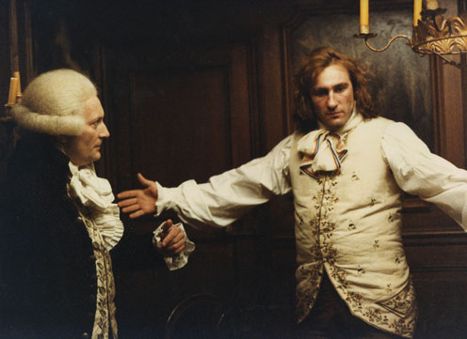
The film, Danton, looks closely at two months during Terror—March and April 1794—and the bitter struggle between Danton and Robespierre over the future course of the Revolution. Danton claims he speaks for the people in calling an end to the Terror, the machinery of which he helped construct. Robespierre, convinced that Terror is still needed, sees Danton as threat to the Revolution. Here are some key characters to take notes about for the press conference preparation.

Georges Danton

Maximillien Robespierre

Sylvestre Lacroix

Camille Desmoulins

Louis Legendre

Robert Lindet

Louis Antoine Saint Just

Héron

Pierre Philippeaux

Fouquier-Tinville

Louis Jean Joseph Léonard Bourdon

Jacques-Louis David

François Joseph Westermann

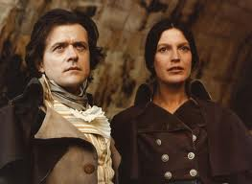
Lucile Desmoulins

