Inelasticity of Demand
Interactively read the following articles regarding the elasticity of demand and then answer the questions:
A rise in gas taxes won't do anything to change people's behavior. Are people going to stop driving to work if prices go up? Are they going to quit their jobs? Are they going to sell their house and move closer to work? Of course not! Higher gas prices do nothing but give the government more of our hard earned dollars.
Of course, one could illustrate all the ways that someone could cut back on fuel consumption in response to higher prices, such as carpooling, going to the supermarket and the post office in one trip instead of two, and so on. What we're really debating is - what is the price elasticity of demand for gasoline? Is it zero? That is, if gasoline rises 10%, what happens to the quantity demanded for gasoline? We do not have to just theorize about how people may respond to a rise in gas hikes, we can look at studies which determine what the price elasticity of demand for gasoline is and how tax policy would effect consumption.
It turns out that there are a lot of studies which calculate what the price elasticity of demand is. Molly Espey, examined 101 different studies and found that in the short-run (defined as 1 year or less), the average price-elasticity of demand for gasoline is -0.26. That is, a 10% hike in the price of gasoline lowers quantity demanded by 2.6%. In the long-run (defined as longer than 1 year), the price elasticity of demand is -0.58; a 10% hike in gasoline causes quantity demanded to decline by 5.8% in the long run.
While we cannot say with absolutely certainty what the magnitude a rise in gas taxes will have on quantity demanded, we can be reasonably assured that a rise in gas taxes, all else being equal, will cause consumption to decrease.
-------
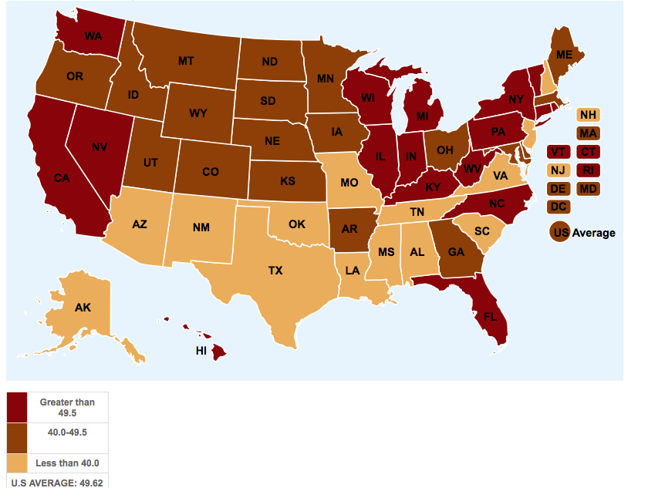
California drivers could be just a few years away from having “black boxes” in their cars tracking their travel and taxing them for every mile driven. Senate Bill 1077 is by Assemblyman Mark DeSaulnier, D-Concord, and would require a mileage tax pilot program to start up by 2016. It recently passed the Assembly Transportation Committee.
Proponents argue that a mileage tax is needed because California motorists are using less gas than in the past because cars are more fuel efficient, reducing much-needed revenue from the 36-cents-per-gallon fuel excise tax. Opponents are concerned about the potential loss of privacy when governmental agencies track Californians’ travel.
Aware of that concern, SB1077 requires a 15-person task force to implement a mileage tax pilot program that takes into consideration “the necessity of protecting all personally identifiable information used in reporting highway use,” according to the committee’s legislative analysis.
Bill author DeSaulnier cited a California Transportation Committee study in explaining the need for his bill to the committee on June 23. California is “$295 billion short on the operations and maintenance of our existing transportation infrastructure,” he said. “And that’s just for the remainder of this decade. So as the gas tax continues to go down, largely because of the efficiency of our fleet and more efficient cars get out, we know that we are approaching pretty quickly a fiscal cliff when it comes to transportation.”
DeSaulnier said a mileage tax needs to be studied. “The study specifically needs to deal with individual privacy issues, equity, technology, costs and consequences of various potential options available,” he said. “So when we look at different options, this would just be one.”
Will Kempton, a former Caltrans director who is now executive director of Transportation California, an advocacy group, agreed that an alternative to the gas tax must be found.
“We’re vitally concerned about gaining more revenues for the transportation program given the needs that have been identified in some of the recent studies,” he said. “The gas tax has been the major funding source for transportation for several decades, but it’s no longer carrying the weight of that charge.
“It looks like the mileage-based fee is an approach or mechanism that has some promise. It’s certainly being talked about across the country at the national level. And we know that several states on the West Coast are taking steps to move more rapidly toward implementation of a user fee of this nature. The Oregon model, I think, is one of the best that we can look at in terms of how we might approach this issue in California.”
But Committee Chairwoman Bonnie Lowenthal, D-Long Beach, is on board with a mileage tax, having sponsored a resolution in 2011 to urge Congress to adopt one at the federal level.
“I think this is a really important bill,” she said. “In my five years as chair of transportation we have been talking about this [funding deficit]. Everyone in this room has to understand the abysmal condition of some of our roads and that we don’t have the money to pay for it. I know we need to do something about the declining gas tax revenue.
“We need to look at this now. I understand very well the privacy issue. But we don’t have any more time. We are going to lose billions of dollars in lost excise tax revenue as fuel efficiency continues to improve – which is a good thing. Finding an alternative to the gas tax is no small matter. It won’t be cheap if we do it right. And we have to do it right.”
While California’s population grew 6 percent from 2005 to 2013, California motorists’ annual gasoline usage declined by 9 percent to 14.4 billion gallons, according to Board of Equalization statistics.
That’s due not only to more fuel-efficient vehicles, but also to the Great Recession reducing the number of cars on the road and a doubling of gas prices in the past decade leading to people taking shorter trips, according to a BOE report.
-------------------
Research by Sivak of the University of Michigan shows that Americans have mostly managed to avoid the temptation to drive more even as they switched to more fuel efficient vehicles, comparing statistics from this year with 2007. In 2014, drivers reduced their driving distances by 6% compared with the first six months of 2007, Sivak said, adding that new-car buyers this year were picking vehicles that had 11% better fuel economy than new-vehicle buyers in 2007.
Americans tend to purchase vehicles that get better mileage in times of high fuel prices and high unemployment, Sivak said. "Some of these changes are economically driven," he said, "but they are also technologically driven."
In California, one change stands out — the increase in hybrid and electric vehicles. In 2002, there were no hybrids available and there were only 3,461 electric vehicles registered in the state. This year, the number of hybrids registered in the state is approaching 400,000, according to the Department of Motor Vehicles, and the number of electric vehicle registrations is nearing 100,000.
Consumer advocates contend that Americans — fed up with the oil industry, dependence on foreign energy sources and high gasoline prices — are venting their frustrations through their driving behavior. "The pain in their wallets is causing them to rethink their lifestyles," said Jamie Court, president of Consumer Watchdog in Santa Monica, a frequent critic of Big Oil. "People tend to be a lot more environmentally conscious when just ignoring it is going to cost them something."
Higher gas taxes in California and incentives to buy electric cars have moved California to the head of the national curve. Still, consumption in the land of the sun while low for the USA is enormous compared to heavily taxed Europeans and the rest of the world.
No one can compete with America when it comes to burning gasoline. Americans consume 1.2 gallons per person each day -- 31 percent more than the second-ranked Canadians. At the start of the summer driving season, U.S. gas prices remained stuck at their highest level of the year after 12 straight weeks of increases. Prices range from $3.38 a gallon in Arkansas to $4.37 in Hawaii. Still, Americans have little to complain about. Imagine shelling out $9.79 a gallon, the price in Norway. Indians and Pakistanis must put in more than a full day work, on average, to afford a single gallon. Only five countries have less pain at the pump than the U.S. does, and four of them are members of OPEC
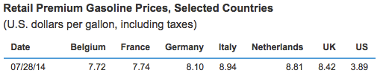
"It shows that ultimately we can solve both the higher emission problem and the higher consumption problem associated with more drivers if we can continue to improve fuel efficiency technology," Court said.

Demand for an economic perspective can be defined as your willingness to buy a good backed up by your ability to pay. Gasoline is a commodity that as seniors in high school, most of you (or your parents) are willing and able to purchase. Therfore, it can be said that you have a demand for gasoline. Fill out the chart you pay below and trace the amount a little more carefully. If your parents buy it ask them.

1, What is the average price you pay for gasoline?_________

2. How many gallons of gas do you normally buy in one week?_________

3. Suppose gasoline prices were as follows. Try and estimate the amount of gallons you would purchase in a week at these prices.

a.) $1.00 _______
b.) $2.00 _______
c.) $4.00 _______
d.) $6.00 _______
e.) $8.00 _______
f.) $10.00 _______

Label the graph and chart these points on the following graph.


During the 1970s, when the price of gasoline skyrocketed, people began to adjust to the price changes by purchasing smaller cars, more sailboats as opposed to motorboats, more bicycles, etc. Since then consumers have resumed buying SUVs and less efficient cars until recently. When it comes to purchasing cars, it seems our first consideration is horsepower rather than gas mileage. This is a puzzling trend considering the continued rise in gasoline prices. This seems contrary to the Law of Demand.

4. What factors do you think caused the resumption of buying of less efficient cars?

5.From your reading what has helped change this trend?

6. Gasoline has always been considered an inelastic commodity. Why?

7. In what ways could people reduce demand in the short term?

8. According to the first article, how inelastic is demand?

9. Imagine you were a state senator in the California senate. What possible externalities would you consider if you decided to vote against the proposed legislation?

10. In the end how would you vote on this newly proposed bill and why?

11. Consider the cost of gasoline worldwide. Imagine a proposal suggested a new $2.00 tax per gallon on gasoline in the USA. Would you support it? Why or why not (paragraph)

12. Headline: Major Discovery Doubles US Oil Reserves
Consider the headline above and answer the following questions on the back in a brief essay. Please read the APGov essay writing standards first prior to answering the questions. (Note you received these in class)

A. Identify the immediate impact of this change on gasoline sellers and buyers
B. Describe what other industries will be affected and how they will be affected
C. Identify the gainers and losers from this discovery and explain what they gained or lost. Support this conclusion with examples.

