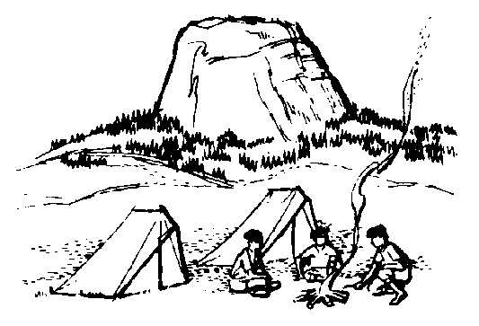
L.I.F.E. Class Personal Backpacking
Equipment Checklist
The following list is a general camping list. You should be aware of any special requirements that you personally may have. Read your permission slip for other items that are needed. Always check the weather report before packing. Remember to Label All Items (especially Clothing!) with YOUR NAME!
Be sure that you have eaten before the assembly time at the school or that you have food to eat while traveling. When we meet at the School you will be expected to help pack the vehicles or bus. You will not eat while others pack for you!
Electronics: The only electronic equipment you may have in camp is a flashlight and camera. Gameboys or other electronic games are not allowed in camp. Do not bring your cell phones. They will not work in the mountains. Adults will have necessary communication equipment.

Equipment required:
- Backpack with hip belt
- Sleeping bag stuffed in 13 gallon plastic bag (for waterproofing) then in stuff sack
- Sleeping pad (ensolite/closed cell foam)
- Suitable hiking shoes
- 1 large (30 gallon, leaf size) trash bag (for rain protection to cover pack) or pack cover
- Journal (min. 5x8 – separate journal)
- Pencil/Pen

Clothing: includes WHAT YOU WEAR
- 3 pairs wool socks or 3 pairs acrylic socks
- 2 pairs liner socks (if needed)
- warm hat
- Sun hat with visor
- Pair long zip off pants
- 1 pair lightweight rain pants
- Synthetic thermals, top and bottom, for sleeping and layering
- Change of underwear (undies and sportsbra)
- Teeshirt, synthetic or 50% cotton
- Woolshirt (or fleece)
- Windbreaker (nylon-light)
- Rain poncho
- Aqua sox (closed toe water shoes) or camp shoes
- Gloves (if you tend to be cold)
- waterproof hiking boots (make sure you wear them often before we go)

Cooking Gear
- 2 water bottles- 1quart each (must be leak proof and smash proof)
- Spoon and 2 cups (or bowl, cup, spoon)
- Waterproof matches or lighter
- Nylon stuff sack for hanging food
- One 13 gallon bag for carrying out garbage
- Two 1-gallon zip bag for carrying out wet food garbage
- 2 hot pot holders (hot pads)

Other Personal Gear
- Comb or brush; hair ties
- Toothbrush: toothpaste
- Small pack towel
- Toilet paper, trowel & medium roll in ziplock bags
- T.P. disposal kit (1 gallon zip, 2 quart zip, 6-8 small zip)
- Feminine hygiene supplies (2 days worth)
- Glasses/case, retainers/case, spare contacts/solution
- First aid kit (Moleskin, bandaids, lip balm (SPF 15+), sunscreen (SPF 15+), antiseptic wipes)
- Whistle
- Sunglasses
- 50 ft. lightweight nylon rope
- 3 bandannas (different colors)
- Small flashlight and/or headlamp: w/extra batteries and bulb
- Emergency repair kit ( Large safely pins, 6 inches duct tape around small stick or pencil, backpack, pins, nail clippers)
- insect repellent

Optional Personal Items
- Binoculars
- Camera and film
- Compass
- trekking poles
- Map (will be provided)
- Personal medicine (in pharmacy container: notify leader if you are bringing any)

Team Equipment (will be split up or taken by leader)
- Shelter with poles and stakes**
- Ground cloth
- Billie kit (stove, pot grabber, towel, scraper, unscented baby wipes, cooking oil, lighter, plastic card for cleaning)
- Spatula, serving spoon (per outing)
- Frying pan (one per outing)
- Fuel**
- Buckets (1-2 per trip); scoop cup; soap
- Camp shovel
- water treatment (filter, tablets, or drops) or a water purifier
- Pocket knife

Items to add or exchange (notes from pack inspection)

Food to bring
TBA

Do Not Bring
Large knife, Books (talk to us for exceptions), Candy
More that 5$, Jewelry, Any illegal subsntaces

